TARPON SPRINGS ELEMENTARY
PARENT/STUDENT HANDBOOK
2019-2020
555 E. Pine St.
TARPON SPRINGS, FLORIDA 34689
Phone: (727) 943-5500
Fax: (727) 943-5580

Mr. Art Steullet
Principal

Visit us on the web: https://www.pcsb.org/tarpon-es

\

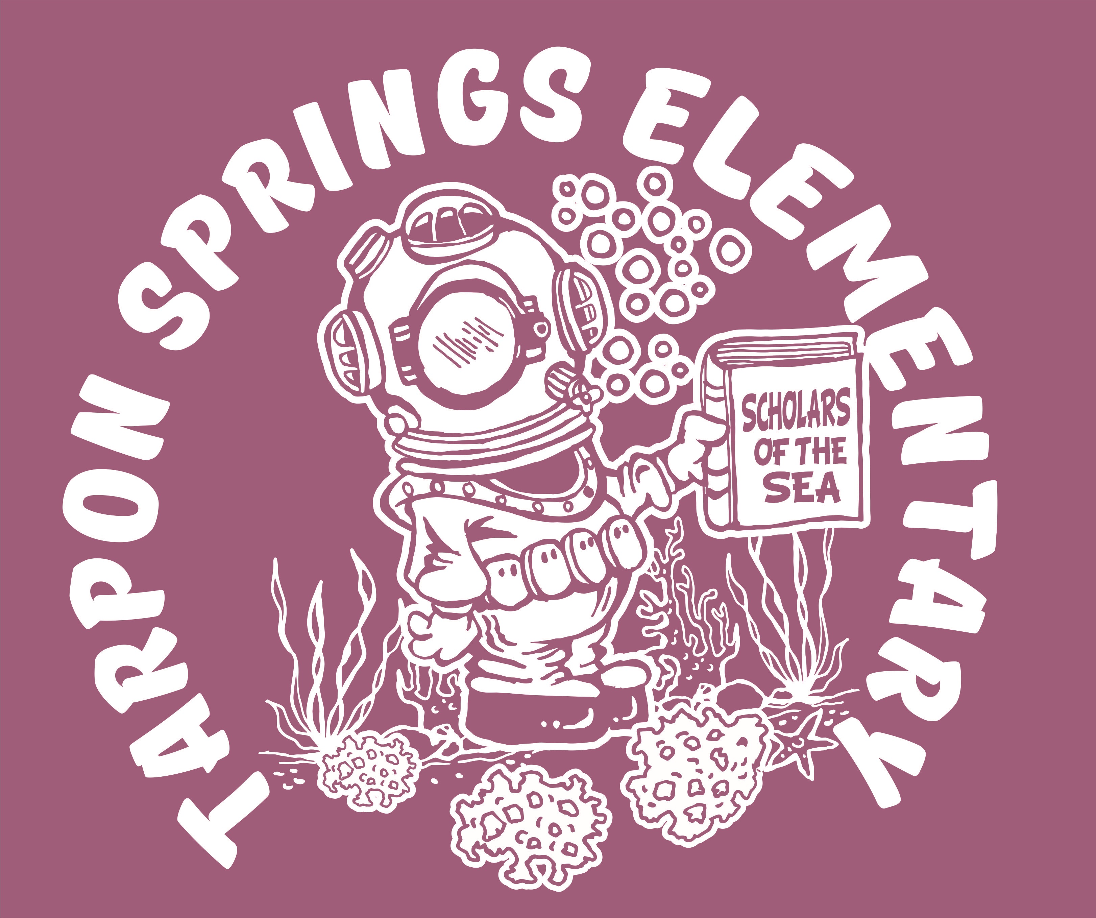

Our Mission Statement
To promote highest student achievement in a safe learning environment.

School Hours: 8:45 AM - 2:55 PM (M-F)
Office Hours: 7:45 AM - 3:45 PM

SCHOOL CONTACTS

Principal.…………………………………..…...Art Steullet
Assistant Principal.………………………....Thea Saccasyn
Secretary/Bookkeeper ………………...…Donna Caplinger
Data Management Technician………………....Nivin Farag
Guidance Counselor ……………………..Joanne Chaisson
Family & Community Relations …….……...Carmen Lake

County Telephone Numbers
Ward Kennedy, Area I Superintendent….…(727)588-5022
Pinellas County Administration Bldg. …….(727)588-6000

Parent Teacher Association
President………………..………………........Stacee Reveron
Treasurer…………………………...……..Helene Hannum
Secretary…………………………….... .....Helen Fatolitis
(Meetings: 1st Meeting 09/18 – remaining meetings TBD. All meetings begin
at 6:00pm.

School Advisory Council
SAC Chairperson…………………………..Liz Monforti
(Meetings: 3rd Wednesday of every month at 3:00 PM in Media Center)

WELCOME! The faculty and staff of Tarpon Springs

WELCOME! The faculty and staff of Tarpon Springs Elementary School would like to take this opportunity to welcome you to our school, home of the “Li’l Spongers.” We look forward to building a relationship with both you and your child. Here at TSES, we are committed to providing our students the best education we can in a safe learning environment. Our goal is to ensure that the instruction your child receives is both stimulating and meaningful. Our goal is to build lifelong learners who are prepared and confident to succeed in today’s modern world.

We offer many quality programs that will help enhance and support your child’s learning while here at TSES. These services include:

- State of the art technology with Smart Boards, laptops and wireless access in every classroom

- ESOL program for speakers of other languages

- School Resource Officer (SRO) in conjunction with the Tarpon Springs Police Department

- Extended Learning Program to provide additional learning time beyond the school day for all students

- Title I program that provides a variety of enhanced student learning and parent training opportunities

- Agenda books for every student to increase the home/school connection.

We believe that every child deserves the best education possible. We are committed to supporting your son or daughter to ensure his/her success here at Tarpon Springs Elementary. With your help and support, we can accomplish this goal. We look forward to working with you this year!

The Staff at Tarpon Springs Elementary

APPOINTMENTS
Students leaving school early must be signed out by a parent or guardian in the school office. The child will be called from class when the parent arrives in the office. No child may leave the school grounds at any time without permission from authorized school staff. Parents picking up a student during lunch need to obtain a visitor’s pass from the office and sign the child out. Every three (3) unexcused early sign outs within a grading period will count as one unexcused absence.

ARRIVAL
Students are permitted on campus at 8:15 a.m. and may go to the cafeteria for breakfast or to the court to wait for the first bell. When the first bell rings at 8:35 a.m., students are to go immediately to their homeroom. Students arriving on campus after 8:45 a.m. will be marked tardy and must report to the office for a tardy pass. Please make every effort to have your child here on time daily. Three (3) unexcused tardies within a grading period count as one unexcused absence.

ATTENDANCE
State law requires daily attendance in school, with acceptable reasons for absence outlined in the Student Code of Conduct. In the event of an absence, communication from the parent is required, such as a phone call to the front office or a note upon return, explaining the student’s absence. Only absences meeting the criteria in the Student Code of Conduct will be excused. Students who have been absent should seek makeup work from the teacher, understanding that the teacher may take up to 24 hours to provide the makeup assignments. Excessive and/or unexplained absences will result in school intervention.

BICYCLES
A bicycle rack located on the north side of campus is available for securing bicycles. Bikes are parked and locked immediately upon arrival at school. TSES is not responsible for bicycles that are lost or damaged. We encourage students to practice safe riding habits by observing all rules of the road and WALKING bicycles across all intersections. Bicycle helmets must be worn by law.

BULLY & HARASSMENT PREVENTION
The Pinellas County School Board and Tarpon Springs Elementary School have adopted a policy that prohibits bullying and harassment. The policy ensures that all students learn in an environment that is safe, secure and free from harassment and bullying of any kind. Processes are in place designed to reduce and prevent bully/victim problems at school by implementing interventions at several levels: school-wide action, classroom level activity, individual interventions and community involvement. If you suspect your child is being bullied, please complete an electronic bullying reporting form at https://www.saysomething.net/

BUS TRANSPORTATION
The bus driver and/or assistant are responsible for the safety students riding the bus to and from school, and students are expected to follow their directions at all times. Any student who engages in disorderly conduct on a school bus will be reported to the principal and may have riding privileges suspended. Students should arrive at their bus top ten minutes earlier than the assigned time, due to fluctuations in traffic patterns. Students must be a registered bus rider to board a school bus and may ride only their own bus. Non-bus riding students may not ride the bus (for example, to visit with a friend) even with parent permission. If parents have questions about bus stops or pick-up times, please contact the school office or the transportation department at (727) 587-2020.

CAFETERIA
Our cafeteria serves breakfast and lunch daily. The State of Florida
participates in a program with the National School Lunch and Breakfast Programs aimed at streamlining eligibility for free meals, the Community Eligibility Option (CEO). Tarpon Springs Elementary
School provides breakfast and lunch at no charge to ALL students. Breakfast is served from 8:15 – 8:35 a.m., and all classes are allocated 30 minutes for lunch. Parents may have lunch with their child, but may not sit in the cafeteria and may not eat with any other children. Anyone without a state issued Level II identification badge must be accompanied by a staff member.

CAR CIRCLE
Please follow the traffic directions of the school personnel on duty. The car circle begins at the corner of Pine Street and Levis Avenue. Pick up and drop off for students may occur only within the area supervised by school personnel.

CELL PHONES & ELECTRONIC DEVICES
According to school board policy students may possess a cell phone or other electronic device on school board property as long as they are powered off and concealed from view while school is in session. Students may NOT use personal cell phones or other devices during the school day. The school is not responsible for loss or damage to personal devices students bring to school. Communication between students and families must occur through the school office when school is in session.

CHILDCARE PROGRAM
The YMCA operates a before and after school child-care program on campus from 6:30 – 8:30 a.m. and 2:50 – 6:00 p.m. Contact the YMCA at (727) 943-7517 or (727) 467-9622 for more information.

CLINIC
Our office clinic, located next to the front office, has a full-time clinic assistant and a part-time registered nurse. In addition to attending to ill or injured students, our clinic staff provides screenings for vision, hearing, height and weight for specific grades. The nurse is available for chronic health problem referrals and upon request will make home visits for parent contact. ONE (1) YELLOW CLINIC CARD AND ONE WHITE STUDENT INFORMATION CARD MUST BE COMPLETED BY THE PARENTS/GUARDIANS AND RETURNED TO SCHOOL AT THE BEGINNING OF EACH YEAR. The information on this card is vital should an accident or injury occur. Please be certain that all information requested is up-to-date. Should any information change, please call the school and notify the clinic staff immediately.

CODE OF CONDUCT
The Pinellas County School Board publishes an updated Code of Student Conduct each year. A copy is sent home with each child the first week of school. The document contains information on school policies, attendance and disciplinary information, as well as information regarding students’ rights. All students and familes are asked to thoroughly review the booklet, complete the “Parent and Student Acknowledgement” page and return it to school.

DISMISSAL
Parents are expected to contact the school in writing if a student is to go home with another student or deviate from the regular method of dismissal. Without this written communication students will be required to dismiss as normal.

EMERGENCY PROCEDURES
Drills to prepare for emergencies, such as fires, lock downs and severe weather are scheduled and conducted, as required by law. Each drill is treated as if it were an actual emergency situation. During a fire drill, everyone on campus evacuates following the assigned route, as quickly as possible. Severe weather drills are held to prepare children to position themselves in a safe area when there is a threat of a tornado. During a lock down drill, all students are sequestered in an assigned location and all campus travel and activity ceases until the lock down has concluded.

EXTENDED LEARNING OPPORTUNITIES
All students have opportunities to extend their learning beyond the school day. Students have access to a variety of computer programs for math and reading. Students can log on to their personal accounts by going to pcsb.org, selecting “Families” at the top and logging in through “Clever.” There are many resources on that page for families, as well.
A variety of clubs will be offered during the year, including math, reading and STEM opportunities. Please speak to your child’s teacher about all extended learning opportunities available to your child.

FAMILY/COMMUNITY INVOLVEMENT & VOLUNTEERS
All parents are encouraged to become involved in their child’s education by registering as a volunteer. Volunteer opportunities include serving as tutors, field trip chaperones, classroom assistants, mentors, or library assistants. If you are interested in volunteering, please contact the school for additional information. A volunteer registration form must be completed and approved prior to volunteering.

FIELD TRIPS
Students participating in school-related field trips must have a completed county field trip form signed by their parent at least one day prior to the trip. Those who do not have this form completed and submitted will remain on campus and be assigned appropriate grade level work.

GUIDANCE COUNSELOR
The elementary guidance counselor works with children, parents and teachers. The major goals of the counselor are:
- To help children enhance their self-concept
- To help children get along with others and develop responsibility
- To help children cope with changes in their lives.
These goals can be accomplished when the counselor, children, parents work together as a team.

GUIDELINES FOR SUCCESS

All students are expected to follow the TSES Guidelines for Success:

T=take responsibility
S=show respect
E=engage in learning
S=show self-control.

Classroom expectations focused on the Guidelines for Success (GFS’s) are developed collaboratively with students. Our “Caught Red-Handed” positive behavior system is used campus wide to recognize and reward students following the GFS’s across campus in common areas.

HEAD LICE POLICY
Should a student be detected with live head lice, Pinellas County Schools policy states the child must be sent home and may not return to school until he/ she has been treated. Policy further states the child must be nit-free upon return to school.

HOMEWORK
Homework is usually assigned Monday through Thursday and is intended to provide an opportunity for children to practice skills learned in school. Occasionally long-range assignments or projects are given to assist students in developing independent study habits. Speak with your child’s teacher for specific information regarding homework expectations in his/her room. Having trouble with homework? The Homework Helpline is providing service to students of Pinellas County's public schools from 5 to 8 p.m. Monday through Thursday. The helpline telephone numbers are (727) 547-7223 or (727) 442-3226.

INSURANCE
Accident insurance is available to all students with forms being sent home at the beginning of school. Claims must be made to the company. Accidents should be reported immediately to the school in order for claim forms to be signed for injuries sustained traveling to and from school, during school, or after school hours for school events. The school system does not provide coverage for student injuries; therefore, you are encouraged to purchase this inexpensive coverage if your child is not otherwise covered.

LEGAL ISSUES
Please inform the principal in writing of legal issues or special circumstances related to your child. This information should be provided on registration day or as soon as possible, if occurring during the school year. Please notify the school office immediately regarding changes in issues such as custody rights, restraining orders, etc. You must bring actual court documents to the school office in order for us to accurately adhere to court orders.

MEDIA CENTER
Our media center, an extension of the classroom, is an area where resources and varieties of literature are housed for the benefit of all students and staff. The media specialist is a resource for both students and teachers. The following applies to all students:
- Books must be checked out from the media center and returned within fourteen (14) days of check out.
- If a book is lost or damaged, repairs or replacement must be made promptly by the student or his family.
NOTE: Florida law states the school can collect from the pupil or parent/guardian the value of lost or damaged books.

MEDICATION
Board policy states that NO medication whether prescription or over-the-counter (OTC) will be administered at school unless the following rules are followed: 1) An orange medication card must be completed and signed by the physician and parent for OTC medications. 2) A blue card is used for prescription permission, and only parent signature is required. 3) Medication MUST be brought to the health room in the original bottle with the student's name, physician's name and directions corresponding to the direction on the medication card. 4) It is against school policy to administer eye or ear drops to any student. If the student is capable, he/she may administer his/her own drops or a parent may administer them in the clinic. At no time should medications be in the classroom unless identified as medically necessary by a physician.

NATIONAL HONOR SOCIETY
TSES is proud to be a member of the National Elementary Honor Society. Participation in the NEHS promotes a positive school climate and provides opportunities for students to reach their greatest potential in school and in life, advocating scholarship, responsibility, service and leadership. Involved students will participate in a variety of ways, including an Honors Chorus program, participation in life-changing service projects and serving as ambassadors for our school. Honor Society membership is a distinction that holds significance throughout a student's academic life—and beyond. For more information, please visit https://www.nehs.org/start-a-chapter/how-nehs-benefits-your-school?SSO=true.

PARENT-TEACHER CONFERENCES
Questions concerning your child's progress can best be answered through a conference. You may arrange for a conference by sending a note or email to the teacher or calling the school office. The individual conference is one of the best means communicating your child's rate of academic growth and development. Please make a sincere effort to attend teacher-requested conferences and to seek conferences yourself when you feel there is a need.
PARTIES
Classrooms may have two parties during the school year, at the teacher’s discretion. Parties scheduled will take place during lunch in the classroom, or the last half hour of the school day. Any food items brought in for students must follow Pinellas County Schools guidelines, which include but are not limited to the following: 1. Must follow the dietary guidelines from the Food Service department; 2. Must be commercially purchased, and cannot be homemade.

Invitations to children's parties outside of school shall not be distributed at school unless the parent chooses to invite all of the students in the class.

PARTNERSHIPS
A partnership is a relationship between a business or individual and a teacher. Monetary donations can be made on several levels: platinum ($200), gold ($150), silver ($100) and bronze ($50). The funds are used to enhance student learning. All levels of partnerships are greatly appreciated.

PHYSICAL EDUCATION AND HEALTH
All children are required to participate in 150 minutes of physical education and/or health instruction each week. Any extended excused absence (3 or more days) must be provided by the child’s physician in writing and filed in the school office. Flat, rubber-soled tennis shoes are required and should be worn at all times for P.E.

RAINY DAYS
Please make arrangements with your child early in the year so that he/she will know what to do during inclement weather. Calling home for instructions will not be allowed. Plan ahead and determine what your walkers and bike riders should do and/or who will transport them. Keep in mind that only those people listed on the card in the office may pick up your child.

REPORT CARDS, PRINCIPAL’S LIST & HONOR ROLL
Report cards are distributed to students four times during the school year. This year’s dates are:
October 29, 2018
January 21, 2020
April 6, 2020
May 29, 2020
Recognition for academic excellence and diligent effort is the purpose of having a Principal’s List and Honor Roll for our intermediate grades. The following criteria will be used only for grades three, four and five. To earn PRINCIPAL’S LIST a student must have all “A’s” in every academic subject and E, V, or S in Art, Music, PE, Conduct, Work Habits and Effort. To qualify for HONOR ROLL students need all “A’s” and/or “B’s” in all academic subjects and E, V, or S in Art, Music, PE, Conduct, Work Habits and Effort.

SAFETY PATROLS
Responsible 4th and 5th graders are chosen to help maintain order and monitor the safety of all children during arrival and dismissal. Infractions of the rules by students will be reported to the school office or the patrol sponsor. Students are recommended for this position on the basis of scholarship, courtesy, cooperation and dependability. It is an honor to be selected for Safety Patrol.

SMOKING
Smoking is prohibited on any part of our campus. This is in compliance with School Board policy.

TITLE I
Our school receives additional funding from the federal government through the Title I School wide Program. The amount of these funds is determined by the number of free and reduced lunch students attending our school. The overall goal of Title I is to enhance our educational programs and promote highest student achievement for all. Research indicates there is a high correlation between parental involvement and student achievement. Therefore, our parents are encouraged to participate in their child’s education through volunteering in classrooms and attending workshops. Numerous activities are held throughout the year for our families. Each year teachers, parents and students sign a Title I Compact, which is an agreement between home and school for sharing the responsibility of student learning.

TRANSFERRING
If transferring from our school, notify your child’s teacher and the
school office staff in advance. Library books and textbooks must be returned and outstanding debts paid before leaving.

UNIFORM POLICY
Our primary responsibility at Tarpon Springs Elementary is to provide your child with the best positive learning experience in a safe environment. We work each day to encourage students to be successful at their job of learning. Our uniform program helps support students’ success and prepares them for their future in today’s work force. The uniform program creates a sense of community and promotes a high level of student achievement. Students are expected to be in uniform every day.

Navy Blue or Khaki Bottoms … Students may wear solid navy blue or solid khaki bottoms in the form of a skirt, shorts, pants, skort or jumper. Shorts and pants must be worn around the waist and fit properly. Students are required to wear a belt if the bottoms have belt loops. No jeans or athletic pants may be worn.
Shirts … Students may wear a collared shirt in solid white, navy or maroon. Shirts may be button down or polo in style. Any brand name logos must not be larger than a quarter. The TSES school spirit T-shirt may be worn on Friday and can be from current or past years. All school spirit t-shirts must have the school name and logo printed.
Cold Weather Wear … A solid white, navy or maroon long sleeved collared shirt may be worn. A long sleeved undershirt may be worn under a uniform shirt, but it must be white, navy or maroon. A solid white, navy, or maroon colored sweatshirt or sweater may be worn indoors or outdoors. Tights in navy, white, or maroon may also be worn under shorts or skirts. Any coat or jacket not in these colors may be worn outside only.
Shoes … Closed toe athletic shoes or dress shoes must be worn daily as part of the uniform. Sneakers are required for PE and are strongly preferred every day. Socks are a required part of the uniform, as well.

Students may be out of uniform for school pictures, identified field trips, and identified attendance celebrations. On these days, it is expected that students follow the Pinellas County Dress Code available online at www.pinellas.k12.fl.us .

VISITORS
All visitors and parents are welcome at our school, but must be accompanied by a staff member unless in possession of a state issued Level II identification badge (Available through the Florida Department of Law Enforcement). It is school board policy that every person sign in at the front office and receive a visitor’s badge which is to be worn at all times while on campus. Visits should not interrupt classroom routines or be a time for impromptu parent conferences. All those wishing to visit classrooms must arrange for an appointment at least 24 hours in advance explaining the purpose of the visit. Visits in excess of thirty minutes in duration will require administrative approval.



